GENERATION OF COMPUTER

**INPUT**

**DEVICES**

**GENERATIONS OF COMPUTER**

**Generation** in computer terminology is a change in technology a computer is being used. Initially, the generation term was used to distinguish between varying hardware technologies. But nowadays, generation includes both hardware and software, which together make up an entire computer system.

There are totally five computer generations known till date. Each generation has been discussed in detail along with their time period, characteristics. We've used approximate dates against each generations which are normally accepted.

**Following are the main five *generations* of computers:**

|  |  |
| --- | --- |
| **S.N.** | **Generation & Description** |
| 1 | **First Generation** The period of first generation: 1946-1959. Vacuum tube based. |
| 2 | **Second Generation** The period of second generation: 1959-1965. Transistor based. |
| 3 | **Third Generation** The period of third generation: 1965-1971. Integrated Circuit based. |
| 4 | **Fourth Generation** The period of fourth generation: 1971-1980. VLSI microprocessor based. |
| 5 | **Fifth Generation** The period of fifth generation: 1980-onwards. ULSI microprocessor based |

**FIRST GENERATION**

The period of first generation was 1946-1959 First generation of computers started with using vacuum tubes as the basic components for memory and circuitry for CPU (Central Processing Unit). These tubes like electric bulbs produced a lot of heat and were prone to frequent fusing of the installations, therefore, were very expensive and could be afforded only by very large organizations.

In this generation, mainly batch processing operating systems were used. In this generation, Punched cards, Paper tape, Magnetic tape Input & Output device were used.There were machine codes and electric wired board languages used.

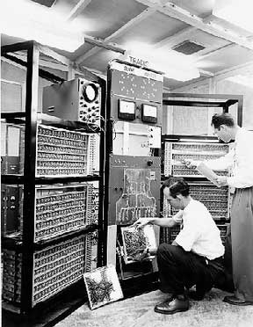

**The main features of First Generation are:**

* Vacuum tube technology
* Unreliable
* Supported Machine language only
* Very costly
* Generate lot of heat
* Slow Input/Output device
* Huge size
* Need of A.C.
* Non-portable
* Consumed lot of electricity
* Some computers of this generation were:
* ENIAC
* EDVAC
* UNIVAC
* IBM-701
* IBM-650

**SECOND GENERATION**

The period of second generation was 1959-1965.This generation using the transistor was cheaper, consumed less power, more compact in size, more reliable and faster than the first generation machines made of vacuum tubes. In this generation, magnetic cores were used as primary memory and magnetic tape and magnetic disks as secondary storage devices.

In this generation, assembly language and high-level programming language like FORTRAN, COBOL were used.

There were Batch processing and Multiprogramming Operating system used.

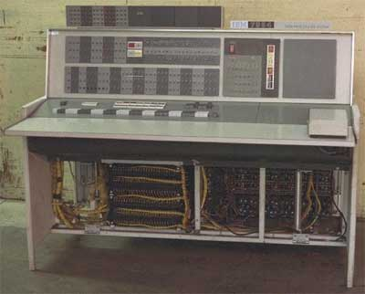

**The main features of Second Generation are:**

* Use of transistors
* Reliable as compared to First generation computers
* Smaller size as compared to First generation computers
* Generate less heat as compared to First generation computers
* Consumed less electricity as compared to First generation computers
* Faster than first generation computers
* Still very costly
* A.C. needed
* Support machine and assembly languages
* Some computers of this generation were:
* IBM 1620
* IBM 7094
* CDC 1604
* CDC 3600
* UNIVAC 1108

**THIRD GENERATION**

The period of third generation was 1965-1971.The third generation of computer is marked by the use of Integrated Circuits (IC's) in place of transistors. A single IC has many transistors, resistors and capacitors along with the associated circuitry. The IC was invented by Jack Kilby. This development made computers smaller in size, reliable and efficient.

In this generation, Remote processing, Time-sharing, Real-time, Multi-programminOperating System were used.

High-level language (FORTRAN-II TO IV, COBOL, PASCAL PL/1, BASIC, ALGOL-68, etc.) were used during this generation

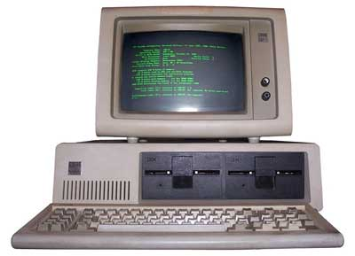

**The main features of Third Generation are:**

* IC used
* More reliable
* Smaller size
* Generate less heat
* Faster
* Lesser maintenance
* Still costly
* A.C. needed
* Consumed lesser electricity
* Support high-level language
* Some computers of this generation were:
* IBM-360 series
* Honeywell-6000 series
* PDP(Personal Data Processor)
* IBM-370/168
* TDC-316

**FOURTH GENERATION**

The period of Fourth Generation was 1971-1980The fourth generation of computers is marked by the use of Very Large Scale Integrated (VLSI) circuits. VLSI circuits having about 5000 transistors and other circuit elements and their associated circuits on a single chip made it possible to have microcomputers of fourth generation. Fourth Generation computers became more powerful, compact, reliable, and affordable. As a result, it gave rise to personal computer (PC) revolution.

In this generation, Time sharing, Real time, Networks, Distributed Operating System were used.

All the higher level languages like C and C++, DBASE, etc., were used in this generation.

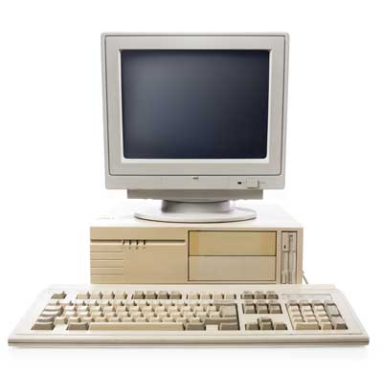

**The main features of Fourth Generation are:**

* VLSI technology used
* Very cheap
* Portable and reliable
* Use of PC's
* Very small size
* Pipeline processing
* No A.C. needed
* Concept of internet was introduced
* Great developments in the fields of networks
* Computers became easily available
* Some computers of this generation were:
* DEC 10
* STAR 1000
* PDP 11
* CRAY-1 (Super Computer)
* CRAY-X-MP (Super Computer)

**FIFTH GENERATION**

The period of Fifth Generation is 1980-till dateIn the fifth generation, the VLSI technology became ULSI (Ultra Large Scale Integration) technology, resulting in the production of microprocessor chips having ten million electronic components.

This generation is based on parallel processing hardware and AI (Artificial Intelligence) software.

AI is an emerging branch in computer science which interprets means and methods of making computers think like human beings.

All the higher level languages like C and C++, Java, .Net, etc., are used in this generation.

**AI includes:**

* Robotics
* Neural networks
* Game Playing
* Development of expert systems to make decisions in real life situations.
* Natural language understanding and generation.

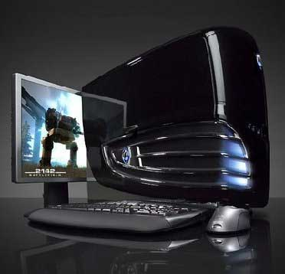

**The main features of Fifth Generation are:**

* ULSI technology
* Development of true artificial intelligence
* Development of Natural language processing
* Advancement in Parallel Processing
* Advancement in Superconductor technology
* More user friendly interfaces with multimedia features
* Availability of very powerful and compact computers at cheaper rates
* Some computers types of this generation are:
* Desktop
* Laptop
* NoteBook
* UltraBook
* ChromeBook

OUTPUT DEVICES

INPUT DEVICES

* Keyboard
* Mouse
* Joystick
* Light pen
* Track Ball
* Scanner
* Graphic Tablet
* Microphone
* Magnetic Ink Card Reader (MICR)
* Optical Character Reader (OCR)
* Bar Code Reader
* Optical Mark Reader

Keyboard

Most common and very popular input device is keyboard. The keyboard helps in putting the data to the computer. The layout of the keyboard is like that of traditional typewriter, although there are some additional keys provided for performing some additional functions.

Keyboards are of two sizes 84 keys or 101/102 keys, but now 104 keys or 108 keys keyboard is also available for Windows and Internet.

The keys are following

|  |  |  |
| --- | --- | --- |
| **Sr. No.** | **Keys** | **Description** |
| 1 | Typing Keys | These keys include the letter keys (A-Z) and digits keys (0-9) which generally give same layout as that of typewriters. |
| 2 | Numeric Keypad | It is used to enter numeric data or cursor movement. Generally, it consists of a set of 17 keys that are laid out in the same configuration used by most adding machine and calculators. |
| 3 | Function Keys | The twelve functions keys are present on the keyboard. These are arranged in a row along the top of the keyboard. Each function key has unique meaning and is used for some specific purpose. |
| 4 | Control keys | These keys provide cursor and screen control. It includes four directional arrow key. Control keys also include Home, End, Insert, Delete, Page Up, Page Down, Control(Ctrl), Alternate(Alt), Escape(Esc). |
| 5 | Special Purpose Keys | Keyboard also contains some special purpose keys such as Enter, Shift, Caps Lock, Num Lock, Space bar, Tab, and Print Screen. |

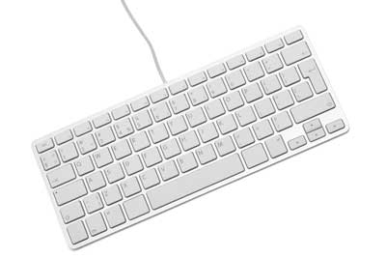

Mouse

Mouse is most popular Pointing device. It is a very famous cursor-control device. It is a small palm size box with a round ball at its base which senses the movement of mouse and sends corresponding signals to CPU on pressing the buttons.

Generally, it has two buttons called left and right button and scroll bar is present at the mid. Mouse can be used to control the position of cursor on screen, but it cannot be used to enter text into the computer.

ADVANTAGES

* Easy to use
* Not very expensive
* Moves the cursor faster than the arrow keys of keyboard.

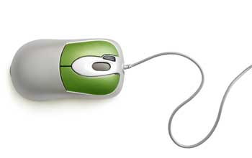

Joystick

Joystick is also a pointing device, which is used to move cursor position on a monitor screen. It is a stick having a spherical ball at its both lower and upper ends. The lower spherical ball moves in a socket. The joystick can be moved in all four directions.

The function of joystick is similar to that of a mouse. It is mainly used in Computer Aided Designing (CAD) and playing computer games.

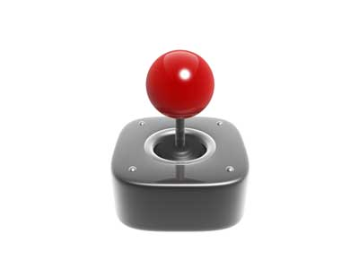

Light pen

Light pen is a pointing device, which is similar to a pen. It is used to select a displayed menu item or draw pictures on the monitor screen. It consists of a photocell and an optical system placed in a small tube.

When light pen's tip is moved over the monitor screen and pen button is pressed, its photocell sensing element, detects the screen location and sends the corresponding signal to the CPU.

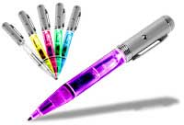

Track Ball

Track ball is an input device that is mostly used in notebook or laptop computer, instead of a mouse. This is a ball, which is half inserted and by moving fingers on ball, pointer can be moved.

Since the whole device is not moved, a track ball requires less space than a mouse. A track ball comes in various shapes like a ball, a button and a square.

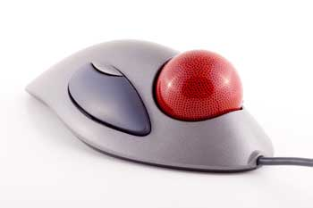

Scanner

Scanner is an input device, which works more like a photocopy machine. It is used when some information is available on a paper and it is to be transferred to the hard disc of the computer for further manipulation.

Scanner captures images from the source which are then converted into the digital form that can be stored on the disc. These images can be edited before they are printed.

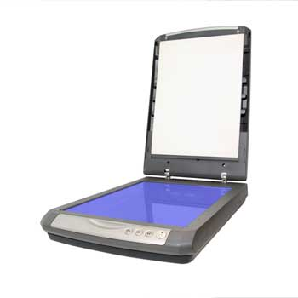

Digitizer

Digitizer is an input device, which converts analog information into a digital form. Digitizer can convert a signal from the television camera into a series of numbers that could be stored in a computer. They can be used by the computer to create a picture of whatever the camera had been pointed at.

Digitizer is also known as Tablet or Graphics Tablet because it converts graphics and pictorial data into binary inputs. A graphic tablet as digitizer is used for doing fine works of drawing and images manipulation applications.

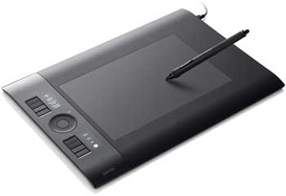

Microphone

Microphone is an input device to input sound that is then stored in digital form. The microphone is used for various applications like adding sound to a multimedia presentation or for mixing music.

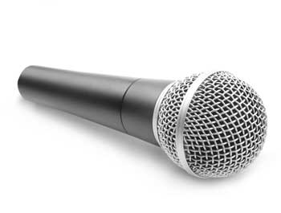

Magnetic Ink Card Reader (MICR)

MICR input device is generally used in banks because of a large number of cheques to be processed every day. The bank's code number and cheque number are printed on the cheques with a special type of ink that contains particles of magnetic material that are machine readable.

This reading process is called Magnetic Ink Character Recognition (MICR). The main advantage of MICR is that it is fast and less error prone.

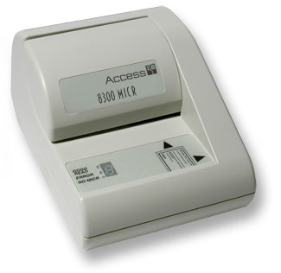

Optical Character Reader (OCR)

OCR is an input device used to read a printed text. OCR scans text optically character by character, converts them into a machine readable code and stores the text on the system memory.

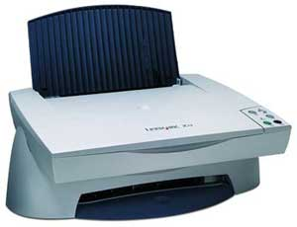

Bar Code Readers

Bar Code Reader is a device used for reading bar coded data (data in form of light and dark lines). Bar coded data is generally used in labelling goods, numbering the books, etc. It may be a hand-held scanner or embedded in a stationary scanner.

Bar Code Reader scans a bar code image, converts it into an alphanumeric value, which is then fed to the computer to which bar code reader is connected.

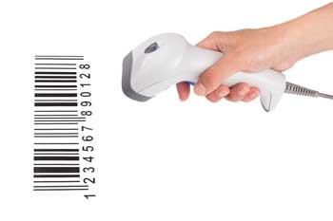

**OUTPUT DEVICES**

Following are few of the important output devices, which are used in Computer Systems:

* Monitors
* Graphic Plotter
* Printer

Monitors

Monitor commonly called as Visual Display Unit (VDU) is the main output device of a computer. It forms images from tiny dots, called pixels, that are arranged in a rectangular form. The sharpness of the image depends upon the number of the pixels.

There are two kinds of viewing screen used for monitors:

* Cathode-Ray Tube (CRT)
* Flat-Panel Display

Cathode-Ray Tube (CRT) Monitor

In the CRT, display is made up of small picture elements called pixels. The smaller pixels are the better image clarity or resolution. It takes more than one illuminated pixel to form whole character, such as the letter 'e' in the word help.

A finite number of characters can be displayed on a screen at once. The screen can be divided into a series of character boxes - fixed location on the screen where a standard character can be placed.

Most screens are capable of displaying 80 characters of data horizontally and 25 lines vertically. There are some disadvantages of CRT:

* Large in Size
* High power consumption

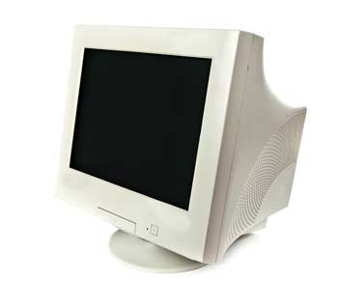

Flat-Panel Display Monitor

The flat-panel display monitor refers to a class of video devices that have reduced volume, weight and power requirement compared to the CRT. You can hang them on walls or wear them on your wrists. Current uses for flat-panel displays include calculators, video games, monitors, laptop computer, graphics display.

The flat-panel display are divided into two categories:

**Emissive Displays** - The emissive displays are devices that convert electrical energy into light. Example are plasma panel and LED (Light-Emitting Diodes).

**Non-Emissive Displays** - The Non-emissive displays use optical effects to convert sunlight or light from some other source into graphics patterns. Example is LCD (Liquid-Crystal Device)

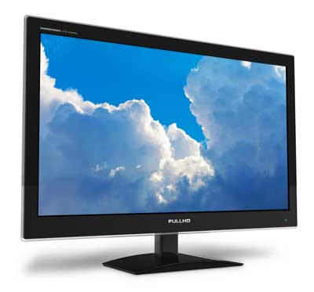

Printers

Printer is the most important output device, which is used to print information on paper.

**There are two types of printers:**

* Impact Printers
* Non-Impact Printers

Impact Printers

The printers that print the characters by striking against the ribbon and onto the paper, are called impact printers.

**Characteristics of Impact Printers are the following:**

* Very low consumable costs
* Impact printers are very noisy
* Useful for bulk printing due to low cost
* There is physical contact with the paper to produce an image
* These printers are of two types:
* Character printers
* Line printers

Character Printers:

Character Printers are printers, which print one character at a time.

**These are of further two types:**

* Dot Matrix Printer (DMP)
* Daisy Wheel

Dot Matrix Printer

In the market, one of the most popular printer is Dot Matrix Printer because of their ease of printing features and economical price. Each character printed is in form of pattern of Dot's and head consists of a Matrix of Pins of size(5*7, 7*9, 9*7 or 9*9) which comes out to form a character that is why it is called Dot Matrix Printer.

**Advantages**

* Inexpensive
* Widely Used
* Other language characters can be printed

**Disadvantages**

* Slow Speed
* Poor Quality

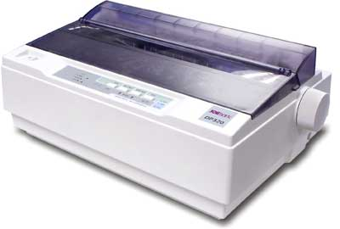

Daisy Wheel

Head is lying on a wheel and Pins corresponding to characters are like petals of Daisy (flower name) that is why it is called Daisy Wheel Printer. These printers are generally used for word-processing in offices which require a few letters to be send here and there with very nice quality representation.

**Advantages**

* More reliable than DMP's
* Better quality
* The fonts of character can be easily changed.
* Disadvantages
* Slower than DMP's
* Noisy
* More expensive than DMP's

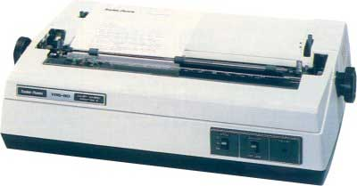

Line Printers

Line printers are printers, which print one line at a time.

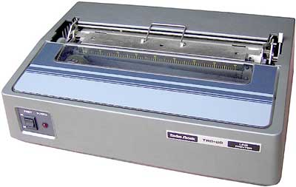

These are of further two types:

* Drum Printer
* Chain Printer